Week 1: Data Familiarization & EDA Report

1. Dataset Familiarization Summary
The DePaul Dataset contains information related to student applications and enrolment activities at DePaul University.

Dataset Structure
- Total Records (Rows): 7,543
- Total Variables (Columns): 80
- Data Types:
  - Numerical Variables: 50
  - Categorical Variables: 30

Initial Observations
- The dataset contains student demographic, academic, and application-related information.
- Most applicants are from India.
- All records are associated with DePaul University.
- Several columns contain missing values and may require cleaning before advanced analysis.
- No duplicate records were identified.

2. Data Dictionary

Variable Name | Data Type | Description
Reference_ID | Integer | Unique student/application identifier
Given_Name | Text | Student first name
Last_Name | Text | Student last name
College | Text | College information
Major | Text | Student major
Degree_Type | Text | Degree type
Country | Text | Applicant country
University | Text | University name
Citizenship | Text | Citizenship information
Status | Text | Application status
Intake | Text | Intake term
City | Text | Applicant city
Region | Text | Applicant region/state
Email_ID | Text | Student email
Application_Source | Text | Source of application
Phone_Number | Text | Applicant contact number
Note: Several variables have unclear naming conventions and require further documentation from the dataset provider.

3. Data Quality Report

Missing Values
Several variables contain substantial missing values. Examples include:
- Most_Recent_Released_Decision
- Date_of_Birth
- Housing_Contract
- Is_Global_Grad
- Is_Admitted
- SEVIS_ID
- RIT_Email_Created
- Official_University_email_address
Many of these columns contain 100% missing values and may be removed during data cleaning.

Duplicate Records
- Duplicate Rows Found: 0

Data Inconsistencies
- Empty fields present in multiple columns.
- Some variables contain incomplete records.
- Standardization may be required for categorical fields.

Recommended Cleaning Actions
- Remove columns with excessive missing values.
- Handle null values appropriately.
- Standardize categorical values.
- Validate email and contact information fields.

4. Exploratory Data Analysis (EDA)

Country Distribution
Top Applicant Countries:
Country | Count
India | 4617
United States | 764
Ghana | 440
Nigeria | 430
Pakistan | 273

Observation:
India contributes the largest number of applications, representing the majority of records in the dataset.

University Distribution
- DePaul University: 100% of records
Observation:
The dataset is focused entirely on applicants associated with DePaul University.

Application Trends
The dataset contains information regarding:
- Student location
- Academic preferences
- Degree type
- Application status
- Recruitment channels
These variables can be used in future analysis to identify enrollment trends and applicant behavior.

5. Visualizations
The following visualizations were created:

Chart 1: Country Distribution Bar Chart
Purpose: To identify countries contributing the highest number of applications.

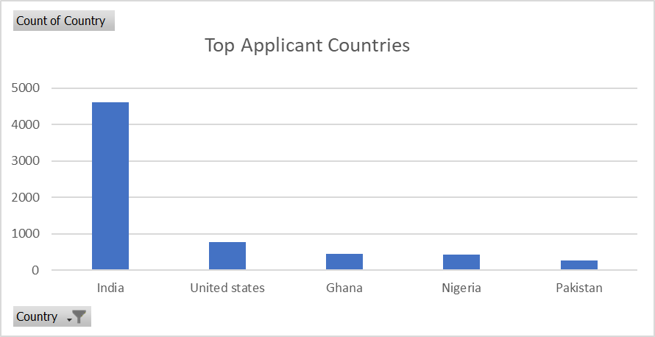

Figure 1: Top Applicant Countries

The bar chart illustrates the number of applicants from the top five countries. India has the highest number of applicants (4,617), followed by the United States (764), Ghana (440), Nigeria (430), and Pakistan (273). This indicates that the majority of applicants originate from India, highlighting a strong concentration of applications from South Asia.\

Chart 2: Application Status Distribution
Purpose:To understand application progress and outcomes.
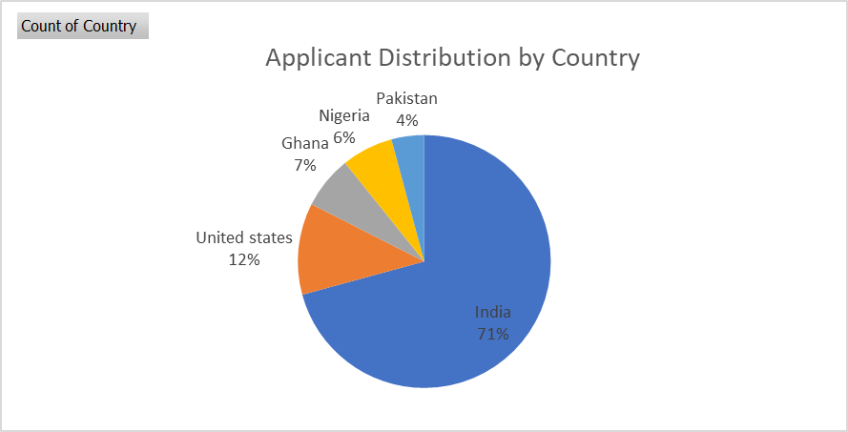
Figure 2: Applicant Distribution by Country
The pie chart shows the percentage distribution of applicants across the top five countries. India represents the largest share of applicants, while the United States, Ghana, Nigeria, and Pakistan contribute smaller proportions.

Chart 3: Intake Distribution
Purpose:
To analyze student intake preferences.
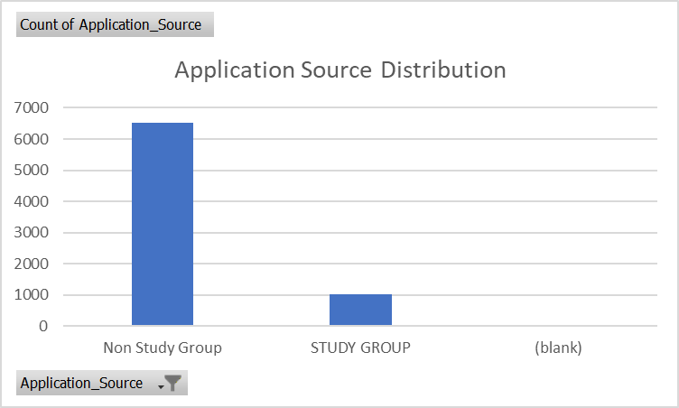
Figure 3: Application Source Distribution
The chart illustrates the distribution of applicants across different application sources. It helps identify the most effective channels through which students apply to DePaul University and provides insights into recruitment performance.

Chart 4: Applications by Top 10 Intakes
Purpose:
To identify the most popular degree categories.
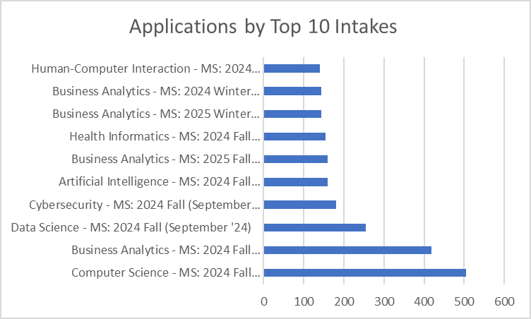

Chart 5: Regional Distribution
Purpose:
To understand geographic concentration of applicants.

6. Insights Summary

Key Findings
- The dataset contains 7,543 application records.
- India is the dominant source country for applicants.
- No duplicate records were detected.
- Multiple variables contain significant missing values.
- The dataset provides extensive information on applicant demographics and academic interests.

Notable Trends
- Strong applicant representation from South Asia.
- Large concentration of records from India.
- University information is highly consistent across records.
- Several administrative fields require cleaning before deeper analysis.

Recommendations for Week 2
- Perform detailed data cleaning.
- Handle missing values systematically.
- Explore relationships between country, degree type, intake, and application status.
- Conduct correlation and trend analysis.
- Build advanced visualizations to support decision-making.

Conclusion
The DePaul Dataset provides a comprehensive view of student application information. Initial exploration identified key demographic trends, data quality concerns, and opportunities for deeper analysis. Further cleaning and advanced analytical techniques will enable more meaningful insights in Week 2.

